**Bucks County Department of Health**

**West Nile Disease Control Guidance (including Tick Information)**

**In the year 2000, the West Nile Virus first appeared in Pennsylvania and it was found that people and animals were contracting the disease after being bitten by a mosquito carrying the virus. Most people infected with the virus have no symptoms, or mild ones such as a fever, body aches, mild skin rash, or swollen lymph glands. However, some people will experience much more severe symptoms, which may lead to encephalitis and occasionally death. In 2018, 128 people were infected with the disease across Pennsylvania, many seriously, and eight people died from the virus.**

**One of the best ways to keep clear of the disease is to avoid going outside early in the morning or at dusk, or to apply a mosquito repellant if you must go outside. You can find the list of approved repellants on the CDC web link below, many of which are also effective against ticks. In addition, make sure screens in your home are in good condition so as to keep mosquitoes outside! Another very important way to avoid the disease is to eliminate mosquito breeding around your home. Mosquitoes can breed in as little as a capful of water, and many people have unattended bird baths, tires, and other containers filled with stagnant water, which are breeding large numbers of mosquitoes. See the diagram below for common mosquito breeding areas around the home. The web sites below give additional information on how to best avoid the West Nile Disease and also tick related diseases (i.e. Lyme Disease).**

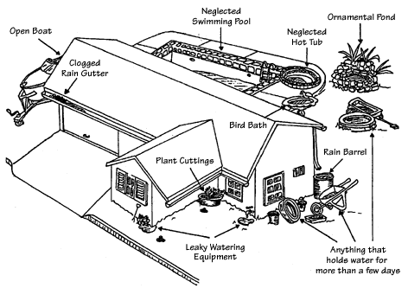

**Penn State’s West Nile Virus Web Site:** [**https://extension.psu.edu/west-nile-virus**](https://extension.psu.edu/west-nile-virus)

**Bucks County Department of Health Web Site and Contact Information:** [**http://www.buckscounty.org/government/healthservices/HealthDepartment/Environmental/WestNile**](http://www.buckscounty.org/government/healthservices/HealthDepartment/Environmental/WestNile)

**Pennsylvania Department of Health West Nile Site:** [**http://www.westnile.state.pa.us/**](http://www.westnile.state.pa.us/)

**CDC West Nile Web Site -** [**https://www.cdc.gov/westnile/prevention/index.html**](https://www.cdc.gov/westnile/prevention/index.html)

**CDC Tick Disease Prevention Web Site:** [**https://www.cdc.gov/ticks/avoid/on_people.html**](https://www.cdc.gov/ticks/avoid/on_people.html)

**Dare to 2B Aware Tick Prevention Program -** [**https://palyme.org/dare-2b-tick-aware/**](https://palyme.org/dare-2b-tick-aware/)